Jeremy Scheuerman

Dr. Wang

Lab 6 part 2

6.4

Option 2

-The 2 input variables are pass by reference the output value is pass by value

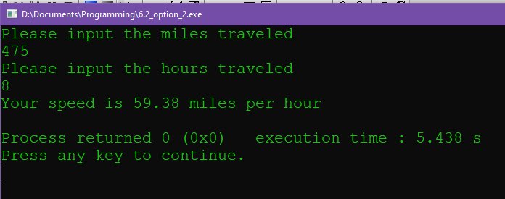

Source Code

#include <iostream>

#include <iomanip>

using namespace std;

float find_mph();

float find_mph(float miles, float hours)

{

float mph=miles/hours;

//define and calculate

return mph;

}

int main()

{

float miles;

float hours;

float mph;

cout<< "Please input the miles traveled"<<endl;

cin>>miles;

cout<< "Please input the hours traveled"<<endl;

cin>>hours;

mph=find_mph(miles,hours);

//return

cout<< "Your speed is "<<fixed<<setprecision(2)<<mph<<" miles per hour"<<endl;

return 0;

}

Option 3

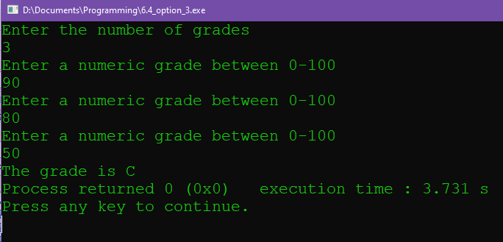

Source Code

#include <iostream>

#include <iomanip>

using namespace std;

float calc_grade();

float calc_grade(int num_grades,float grade_total)

{

float final_average;

//define

final_average=grade_total/num_grades;

//get average

return final_average;

}

int main()

{

int num_grades=0;

int sum_grades=0;

char letter_grade;

float final_average=0;

//define

cout<<"Enter the number of grades"<<endl;

cin>>num_grades;

for (int i=0; i<num_grades; i++)

//get input of grades

{

int temp=0;

cout<<"Enter a numeric grade between 0-100"<<endl;

cin>>temp;

sum_grades+=temp;

}

final_average=calc_grade(num_grades,sum_grades);

//get letter grade

if ((final_average<=100)&&(final_average>=90))

{

letter_grade='A';

}

else if ((final_average<=89)&&(final_average>=80))

{

letter_grade='B';

}

else if ((final_average<=79)&&(final_average>=70))

{

letter_grade='C';

}

else if ((final_average<=69)&&(final_average>=60))

{

letter_grade='D';

}

else if ((final_average<=59)&&(final_average>=0))

{

letter_grade='F';

}

else

{

letter_grade='X';

//if grade is outside of range give it X as error

}

cout<<"The grade is "<<letter_grade;

return 0;

}